NEtwork Topolgies

## What is a network topology?

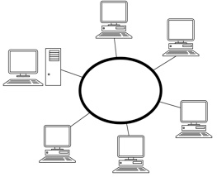In simple terms, A Network Topology is a visual representation of the structures found in a usual network.

The shown diagram is a popular format of a common network topology commonly used in network scenarios.

## Bus Network

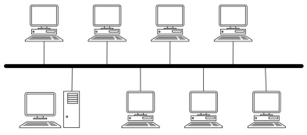This network structure has one central “bus” cable; this is connected to all computers and connects them all together. However, this type of network, although cheap to install, can be quite slow; especially as all computers are sharing the same cable and therefore a shared speed limitation. This type of network will also stop working if there is a breakage in the cable.

## Ring Network

This arrangement of computers is similar to a bus network. However, it is less prone to breakages (although at this stage it will become classed as a bus network). This is because, as there is a ring, it would have to be broken twice for there to be any computers disrupted. This type of network also has less maximum delay than a bus network, as there are more adjacent computers and a lower range between each system.

## Star Network

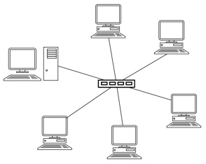Star Topology is a network organized with one central computer; this is comparable to the internet and most websites. A *hub* or *switch* is used at the centre of the network. However, this is quite expensive to install, as it requires a central device and a lot of networking cable. The network can cope with a breakage (and only one computer will be affected), and is very fast as each computer has its own dedicated cable. If the central device stops functioning, the entire network goes down.

## Hybrid Networks

While these aren’t a specific topology by definition; A Hybrid Network combines multiple types of topology, such as multiple star networks that are linked together. This is typically used for big websites, such as google, to increase availability in case of a server failure